Instructions for annotating Errors
We are using the online platform INCEpTION for annotation. Here you will find the 5 translated texts to be annotated. We will also email these, together with the 3 English source texts. You should also receive a separate email from Peter Kleiweg with a username and password for INCEpTION.
After logging in, you can choose ‘Annotations’ in the menu on the left side. You will then see the text allocated to you. Click on the title of the text you want to work on and the text will open ready to be annotated.
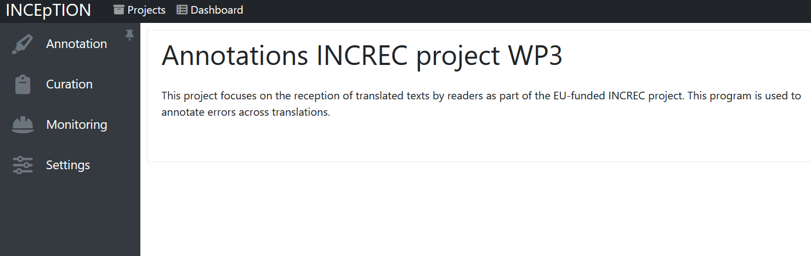

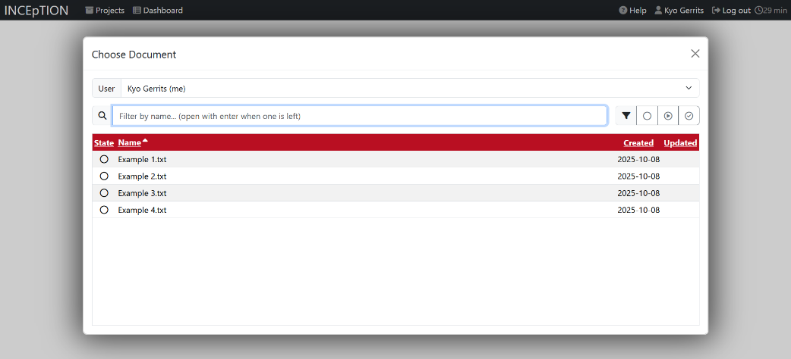
Figure 1: The screen you see after logging in. On the left you can click ‘Annotation’ to start annotating (Please note: you will not likely not see the options for ‘curation, monitoring and settings).

Figure 2: The screen you see after clicking ‘Annotation’. You can go to one of the texts to start annotating by clicking on the title of the document.
Annotating is quite intuitive: select the sentence, word or group of words containing an error and you will see a menu appear on the right side of the screen to indicate which type of error it is (see Figure 3-5 below). Choose which type of main error you have selected. After this an extra choice pops up to select the subcategory of error (this is optional). Select the severity of the error and you can then leave a comment motivating your choice/severity/etc if you want.
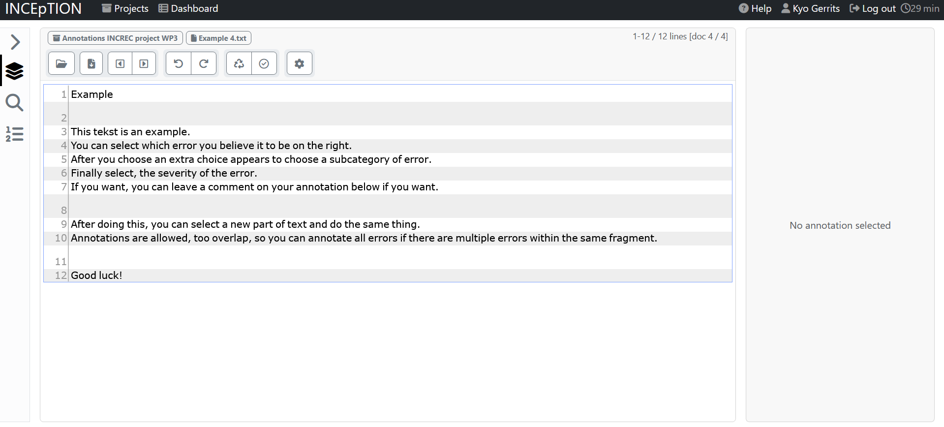
Figure 3: The interface you will see when first opening a text, before annotating anything
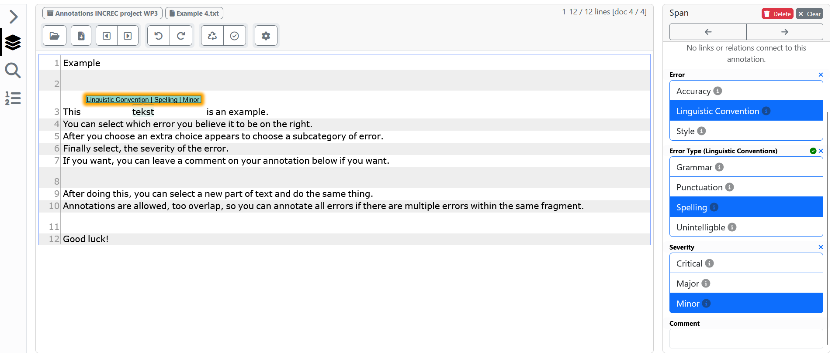
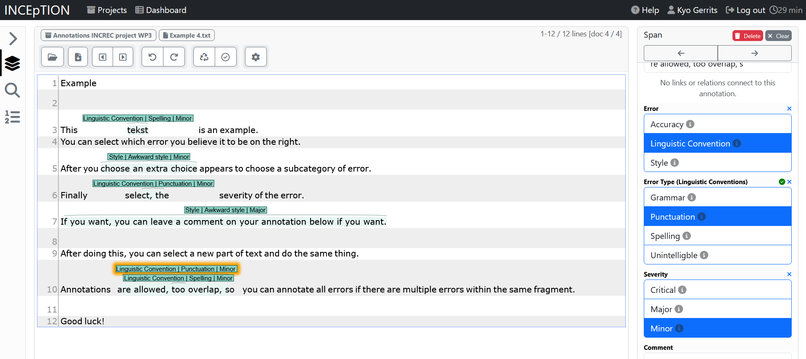
Figure 4: After selecting the first word ‘tekst’ the menu on the right appears and you can select the error, the error type and the severity.
Figure 5: An annotated text. You can see the ‘double’ annotation within the same segment on line 10.

Once you have finished annotating the entire text you can click the check icon (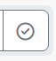) at the right in the beam above after which the annotation are saved. If you aren’t finished immediately with a text you can open and close the page as often as you want. Do you want to change anything after having clicked the check icon, this is also possible by opening the text again and ‘undoing’ the check by clicking the check icon again after which it will go back to the white/not-selected version.
Annotate all translations in this way and let us know when you are finished so we can collect the annotations and set up your payment.
The categories are based on the MQM framework. Within the INCEpTION interface you can see the descriptions of the categories by hovering over the information button (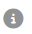) . We also include an overview of the errors, their (sub)categories and their severities on the next pages.
If you have any questions or if anything is unclear, we can always discuss this via email or hop on a quick call to discuss and clarify anything.
We hope these instructions have made the process clear and we wish you the best of luck with the annotations. Please get in contact if anything is unclear or if you have any questions.

Types of Errors
There are three main errors and an option for Kudos:
- Accuracy:
Errors occurring when the target content does not accurately correspond to the propositional content of the source text because of distortion, omission, or addition to the message.
- Linguistic Convention (also known as “Fluency”):
Errors related to the linguistic well-formedness of the text, including problems with grammaticality, idiomaticity, and mechanical correctness.
- Style:
Errors occurring in a text that are grammatically acceptable but are inappropriate because they deviate from organizational style guides or exhibit inappropriate language style.
- Kudos:
Not an error, but to mark a exceptionally good translation solution. Used to praise for exceptional achievement.
Each of these main error categories can be further subdivided (choosing the subcategory is optional).
- Accuracy:
  - Addition: Error occuring in the target content that includes content not present in the source.
  - Omission: Error where content present in the source is missing in the target.
  - Mistranslation: Error occuring when the target content that does not accurately represent the source content.
  - Overtranslation: Error where content present in the source is missing in the target.
  - Undertranslation: Error occuring in the target content that is inappropriately less specific than the source content.
  - Untranslated: Error occuring when a text segment that was intended for translation is omitted in the target content.
- Linguistic Convention:
  - Grammar: Error that occurs when a text string (sentence, phrase, other) in the translation violates the grammatical rules of the target language
  - Punctuation: Punctuation incorrect according to target language conventions.
  - Spelling: Error occurring when a word is misspelled.
  - Unintelligible: Text garbled or incomprehensible.
- Style
  - Awkward style: Style involving excessive wordiness or overly embedded clauses, often due to inappropriate retention of source text style in the target text.
  - Inconsistent style: Style that varies inconsistently throught the text.
  - Register: Characteristic of text that uses a level of formality higher or lower than required by the specifications or general language conventions.
  - Unidiomatic style: Style that is grammatical, but unnatural.
  - Audience appropriateness: Error where content uses a culture-specific reference inappropriately or offensively.
Severity of Errors
Besides annotating the type of error, we would also like to ask you to indicate the severity of the error. We use the following categories for severity:
- Minor:
Errors that don't lead to loss of meaning and wouldn't confuse or mislead the reader but would be noticed, would decrease stylistic quality, fluency or clarity, or would make the content less appealing.
- Major:
Errors that may confuse or mislead the reader or hinder the understanding of the text due to significant change in meaning or because errors appear in a visible or important part of the content.
- Critical:
When the text departs seriously from the source text and has a large impact on the understanding of the entire story. Errors that may misrepresent or damage the reputation of the author or publishing house, causes the text to stop working as a literary artefact and affects the communicative flow or if the the language is perceived as offensive (when unintended).

